Lenah Run Froggers Swim Team
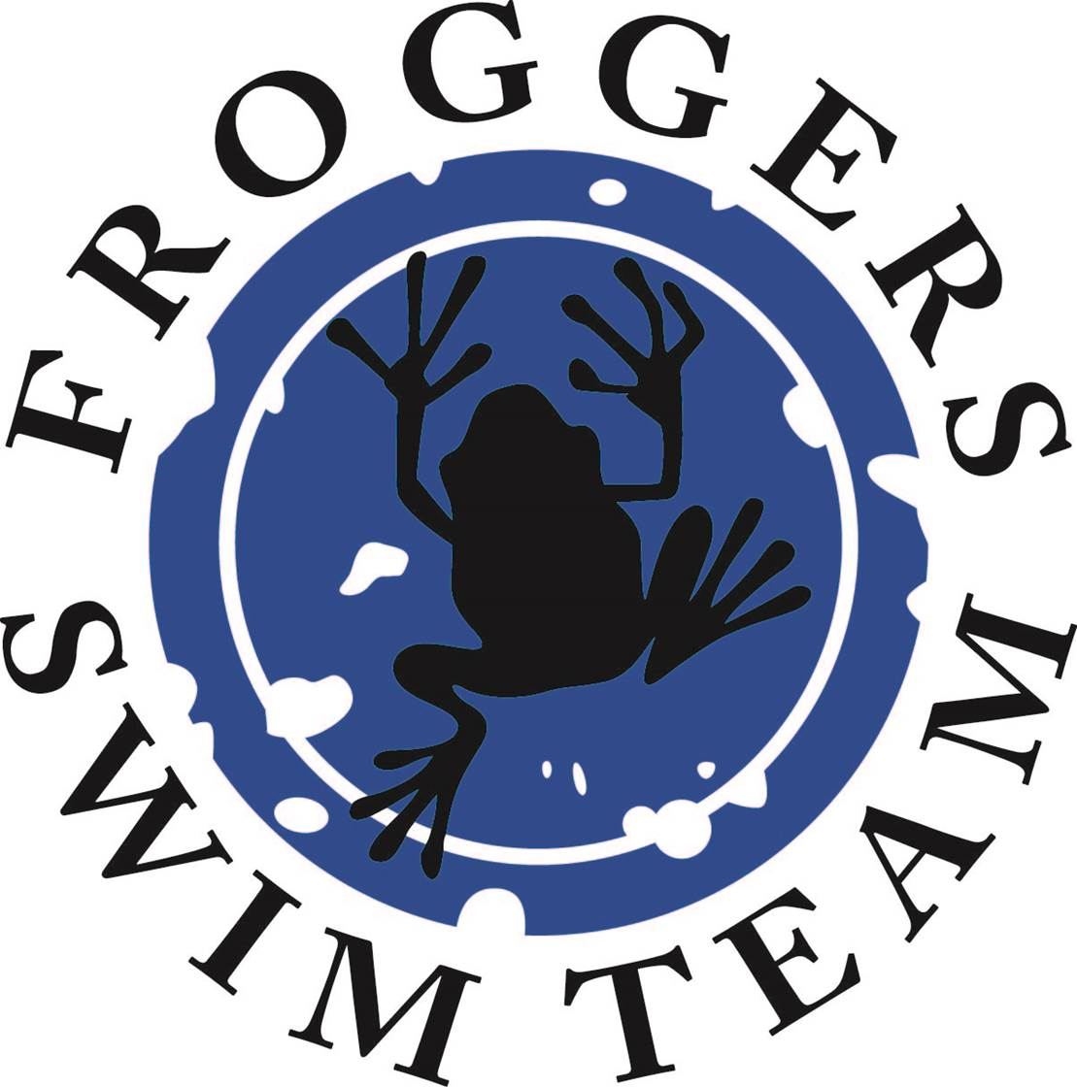

2017 Assistant Coach Application

The Lenah Run Froggers Swim team is seeking professional, dedicated, mature Assistant Coach for the 2017 summer season. We are looking for someone that can take a leadership position in our team's development. The successful candidate should possess the following skill set:

- Possess a high level of maturity, sportsmanship and leadership ability.
- Possess willingness to respect, work and cooperate with the Head Coach, swim team members, parents, and any other members or guests of Lenah Run.
- Demonstrate energy and enthusiasm for teaching and motivating young swimmers of all ability levels including pre-competitive and competitive level swimmers.
- Possess a depth of knowledge and ability to teach and develop proper swimming techniques:
- Emphasizes stroke and turn fundamentals with encouragement and praise
- Uses demonstrations and/or presentations
- Provides constructive feedback
- Understand swim team practice training procedures and keep athletes engaged in productive activity.
- Understand standards of behavior and use appropriate discipline when necessary.
- Knowledge of latest safety standards and information related to aquatics; Lifeguard Training, First Aid, and CPR is not required, but a plus.
- Required to have Pool Ops Certification and Background Check.

If you are interested in applying for this position, please send your resume to: Kevin Piotter at kpiotter@globalbusinessintel.com.

